**DAILY ONLINE ACTIVITIES SUMMARY**

|  |  |  |  |  |  |  |  |  |
| --- | --- | --- | --- | --- | --- | --- | --- | --- |
| **Date:** | **27 June 2020** | | | | | **Name:** | **Sana F Habib** | |
| **Sem & Sec** | **6th sem & B sec** | | | | | **USN:** | **4AL17CS081** | |
| **Online Test Summary** | | | | | | | | |
| **Subject** | | 9:15 am to 11:00 am – Dbms and Jdbc  11:10 am to 1:00pm . | | | | | | |
| **Faculty** | | 1.Hemanth  2Sayeesh | | **Duration** | | | **4 hours** | |
| **Certification Course Summary** | | | | | | | | |
| **Course** | **Career Edge** | | | | | | | |
| **Certificate Provider** | | | **TCS** | | **Duration** | | | **20 days** |
| **Coding Challenges** | | | | | | | | |
| **Status: Executed** | | | | | | | | |
| **Uploaded the report in Github** | | | | | **YES** | | | |
| **If yes Repository name**  **Pre-Placement Activity** | | | | | [**https://github.com/sanahabib2409199/Sana-F-H.git**](https://github.com/sanahabib2409199/Sana-F-H.git)  **(coding)**  [**https://github.com/sanahabib2409199/PrePlacement-Activities.git**](https://github.com/sanahabib2409199/PrePlacement-Activities.git)  **(Schema and ER-Hemanth sir)** | | | |
| **Uploaded the report in slack** | | | | | **YES** | | | |
|  | | | | |  | | | |

Certification Course Details: (Attach the snapshot and briefly write the report for the same)

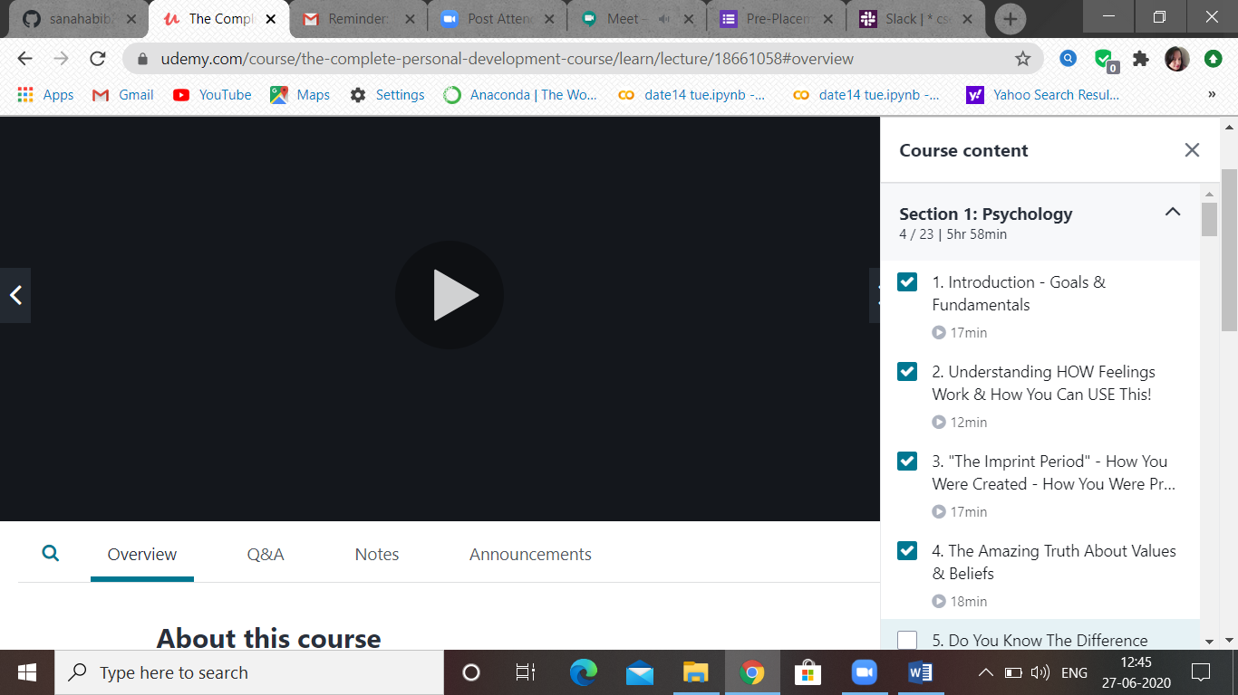

(27-06-2020)-Udemy-session1 Psychology-sub-topics.

Quiz –Dbms and Jdbc:-

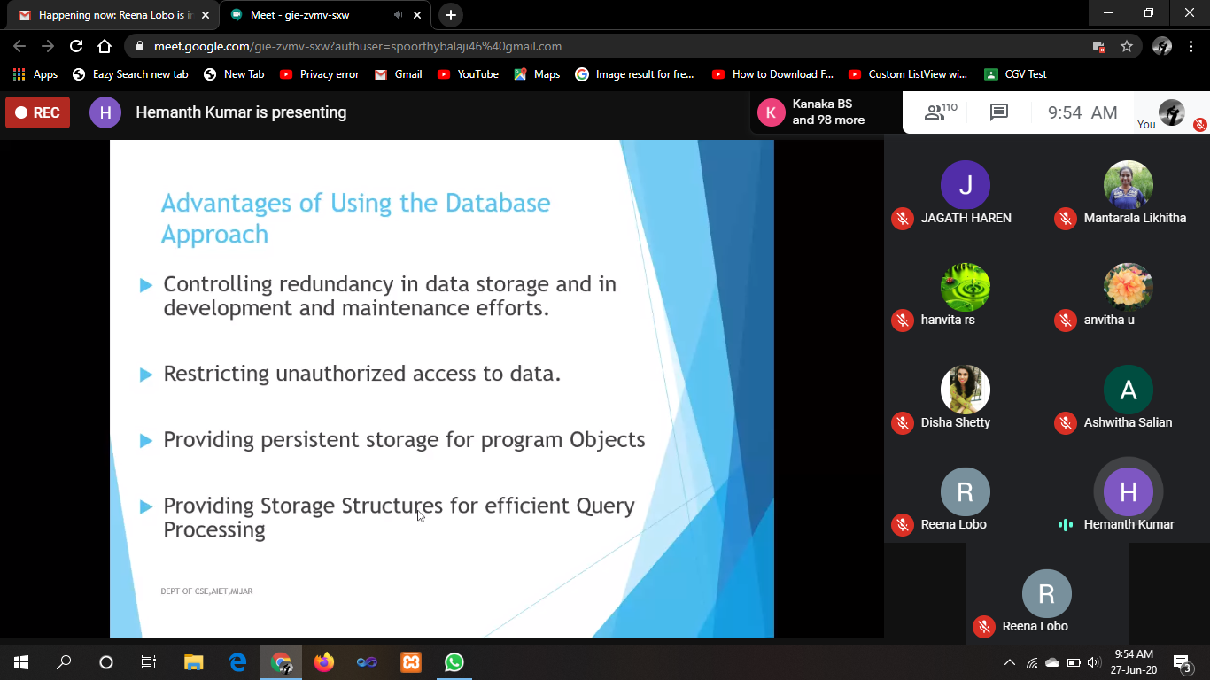

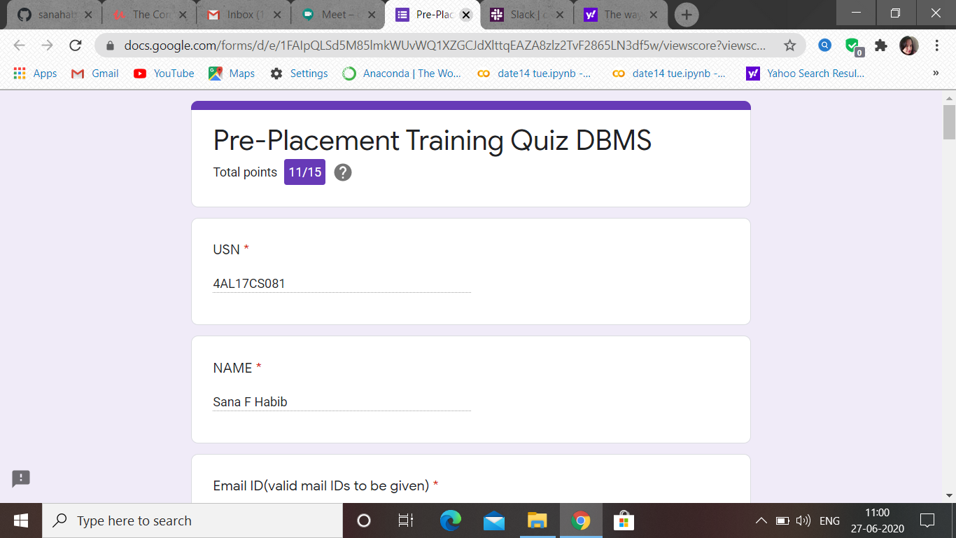

JDBC:-

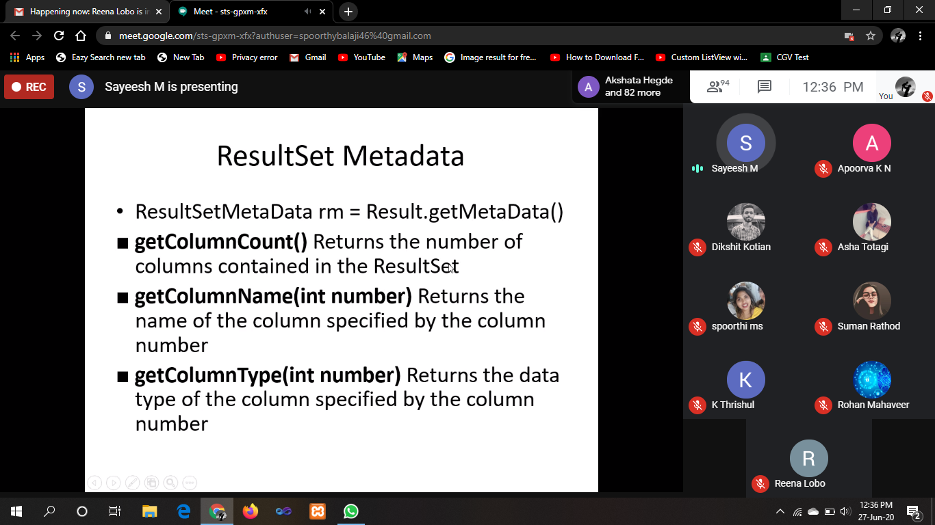

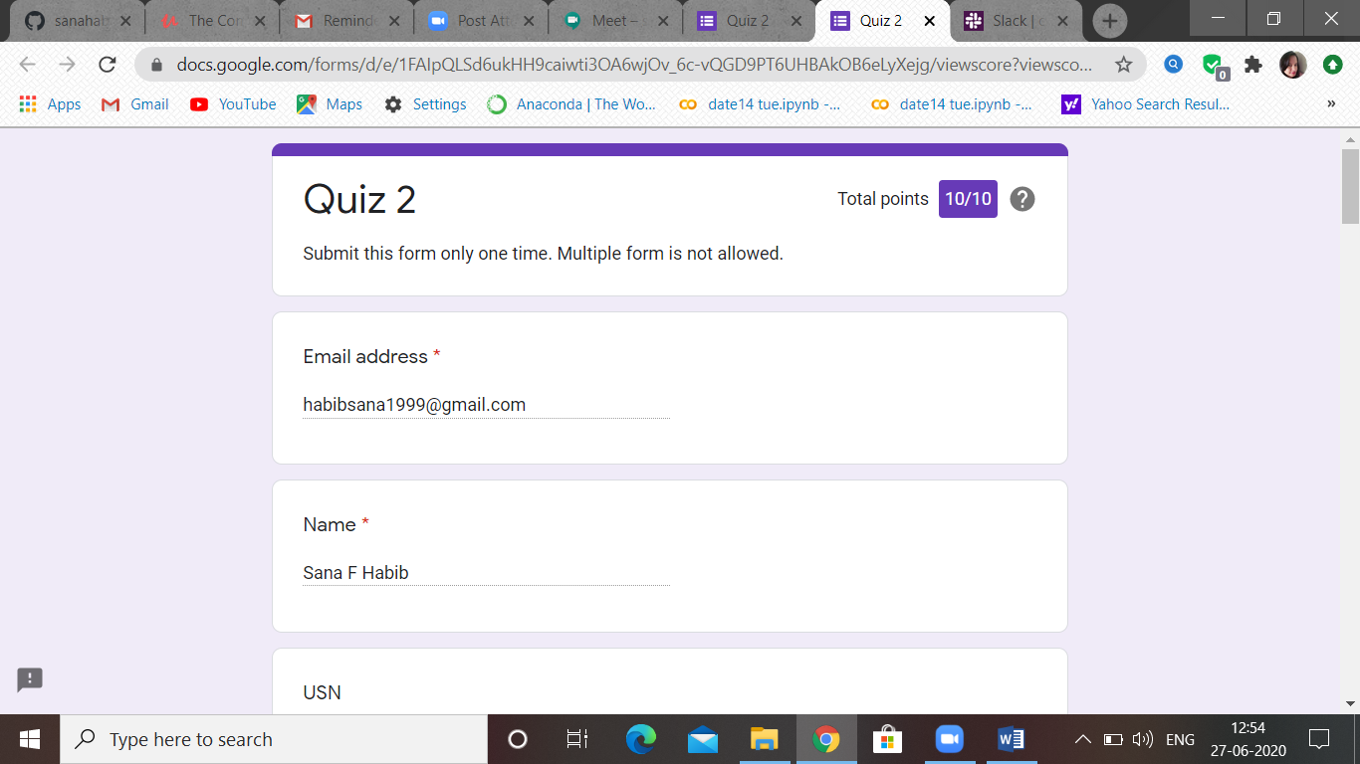

Webinar-IIDE-:

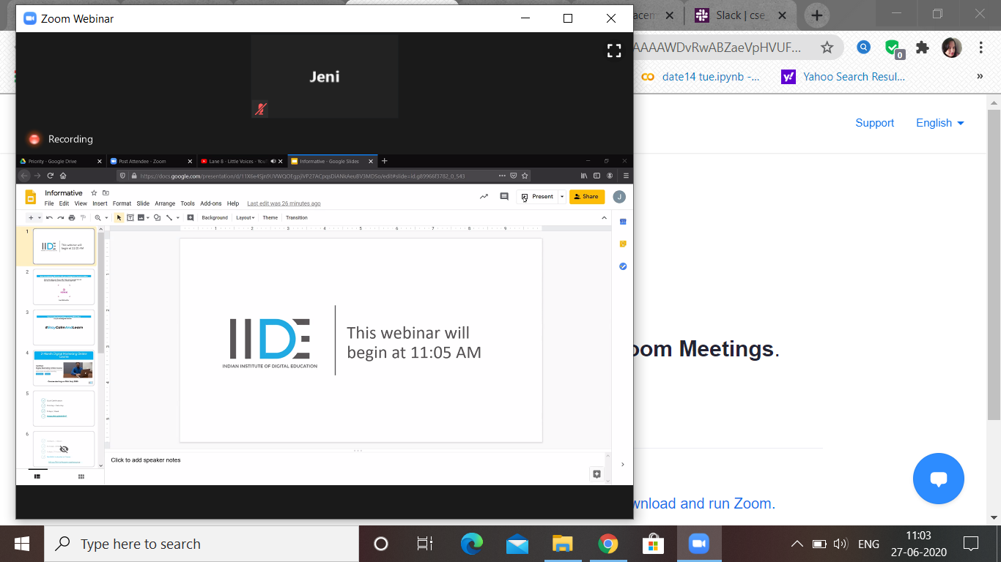

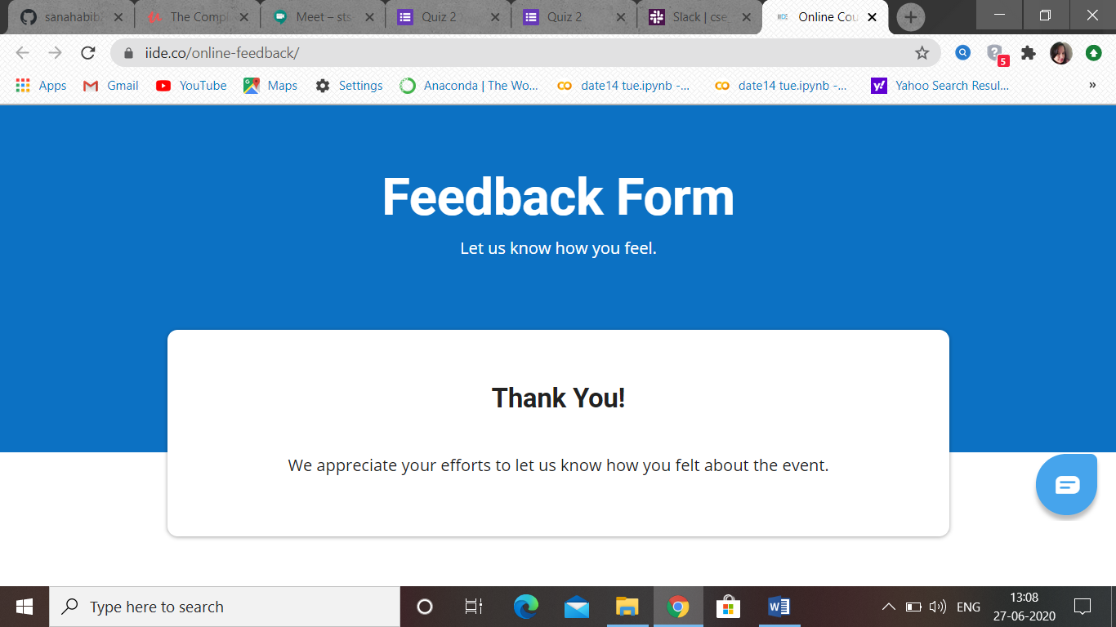

https://github.com/sanahabib2409199/PrePlacement-Activities.git

1-

Student (snum: integer, sname: string, major: string, level: string,age: integer)  
Class (name: string, meets at: string, room: string, d: integer)  
Enrolled (snum: integer, cname: string)  
Faculty (fid: integer, fname: string, deptid: integer)

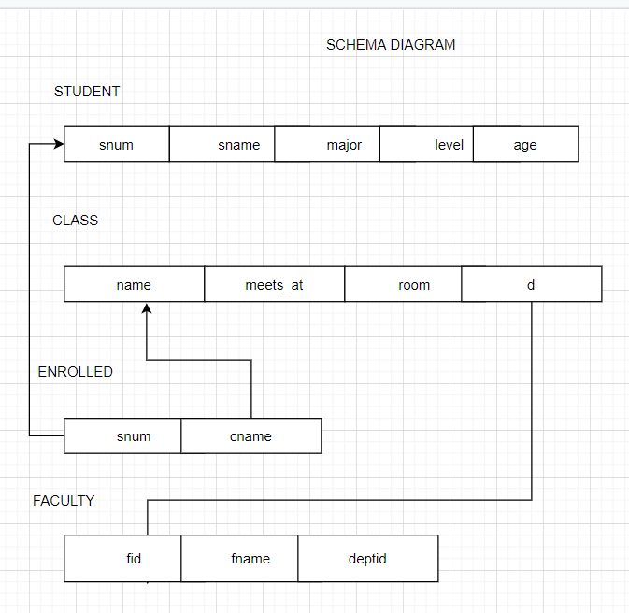

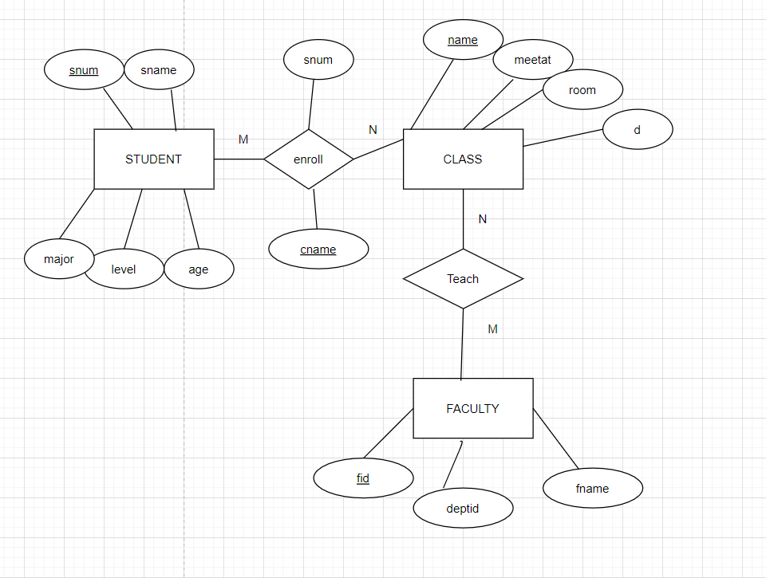

2-

BRANCH(branch-name:string,branch-city:string,assets:real)  
ACCOUNT(accno:int,branch-name:string,balance:real)  
DEPOSITOR(customer-name:string,accno:int)  
CUSTOMER(customer-name:string,customer-street:string,city:string)

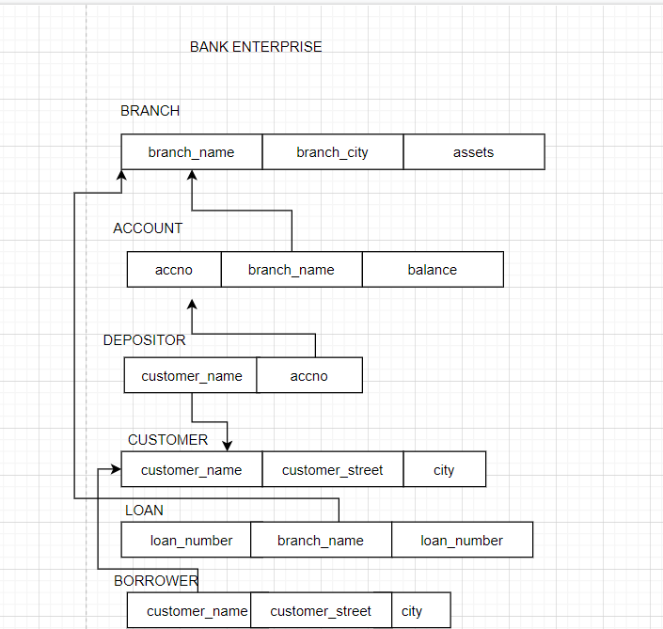

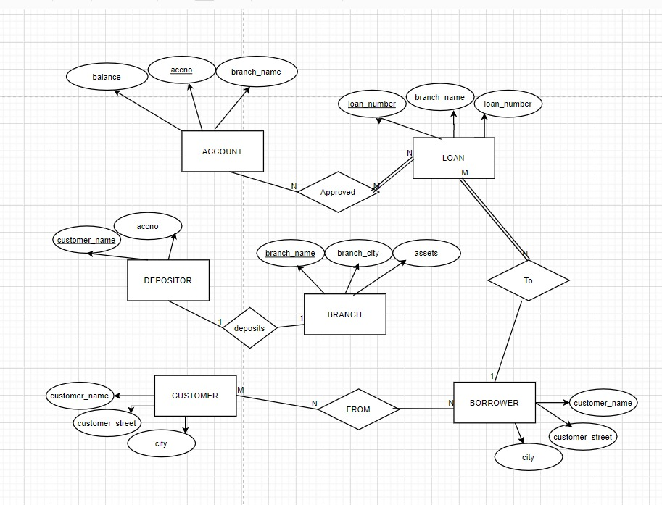

Coding Challenges Details: (Attach the snapshot and briefly write the report for the same)

Program 1

